# 

# Introduction

The following is a list of tests with various composite materials. Each test includes lessons learned, fiber used, matrix used, and overall quality descriptions.

## Test 1 – 12-16-2023

* Fiber – Bondo fiberglass by 3M (PN: 20128)
* Matrix – Bondo fiberglass resin and hardener combo by 3M (PN: 20124)
* Vendor – Home Depot
* Description:
  + This was the first test of composite manufacturing at a hobby level. The goal of this test and likely the following test(s) was to judge the production quality of a mold and layup using the financially cheapest and least intensive methods possible. It is well known that the result would not be anything near as good as professional grade productions. The intent is to use the knowledge captured to advance the attention on only the most lackluster parts of the manufacturing process in order to avoid wasting money on parts that can be done for cheap.
  + The mold selected was an RC foam wing with an outer layer of tape and paint protecting the inside foam. This RC wing had seen an unknown number of flight hours previously. The surface of the mold was NOT cleaned prior to layup. Locally sourced fiberglass, resin, and hardener were purchased from Home Depot. No release film or release agent was applied to the mold prior to layup. The layup was held in place by gravity and matrix was manually dispersed using hand tools and gloved hands. No vacuum bagging techniques were used.
  + Surprisingly, the fiberglass mold, though severely underperforming by any standards, did release from the mold with no noticeable damage to the mold aside from capturing some of the paint. It would be interesting to see if the RC wing with tape exterior could survive multiple layups without release agent, or exothermal curing reactions, without degradation.
* Quality – 3/10
  + Inconsistent matrix, severely lacking stiffness, surprisingly clean release from untreated mold, some areas of fiber disturbance prior to cure.
* Lessons learned:
  + Certain surfaces may not need a release agent, which would be pleasant, since plastic release films require careful constraining to avoid wrinkles. The specific matrix mixture created potent fumes similar to gasoline. More ventilation perhaps. Experiment with humidity exposure in the future. Experiment with laminates and multiple layers of matrix applied at certain time intervals.
* Pictures:

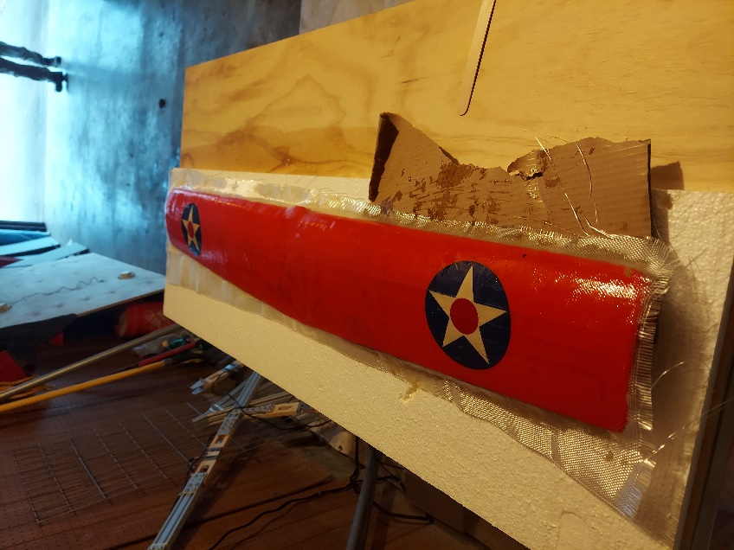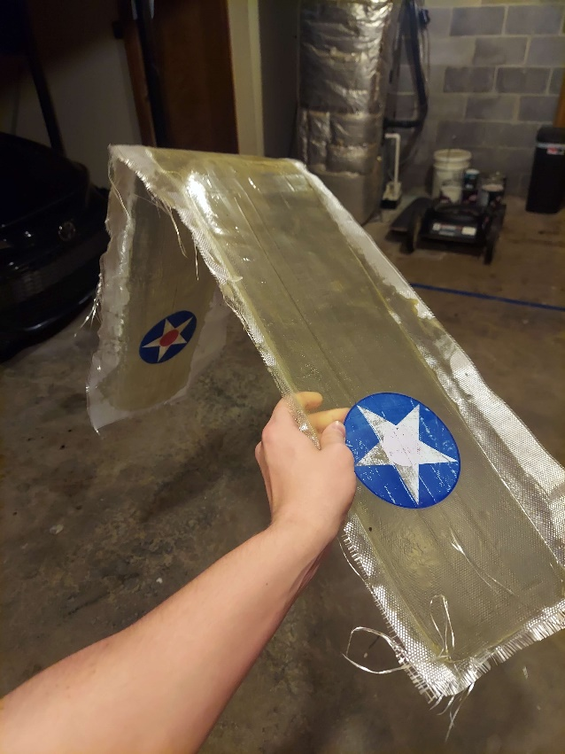

## Test 2 – 12-26-2023

* Fiber – Bondo fiberglass by 3M (PN: 20128)
* Matrix – Bondo fiberglass resin and hardener combo by 3M (PN: 20124)
* Vendor – Home Depot
* Description:
  + This test is a follow-up of Test 1. We are looking to see if the layup will easily release from the mold like in Test 1. There will be a 2nd coat of resin approximately 45 minutes after the first coat. Humidity was measured to be 45% for the first coating and 47% for the 2nd coating. All other facets of test 2 mimic those of test 1.
  + Extra attention was given to removing small air bubbles that was not given during test 1. Not all bubbles could be removed before the end of the time limit however.
  + After 24 hours on the mold after the 2nd coating, the composite was removed.
  + It would be interesting to analyze how peeling off the mold affects durability
    - i.e. does this method result in micro fissures in the composite and if so, what do those micro fissures contribute to yield strength and lifespan?
  + After removing this mold minor damage was seen on the tape mold. It is worth noting however, that the age of the mold is unknown and the removal method was not optimal.
* Quality – 5/10
  + Top surface is very smooth considering no post processing was done (with the exception of the occasional bubble).
  + The bottom surface is relatively smooth but would require some post-processing to remove markings left by the tape edges and imperfections covering the mold. For wings only experiencing positive AOA this probably would not affect performance much.
  + Test 2 is stiffer than test 1 but not by much. It cannot support its own weight when cantilevered unless occasional wing ribs are in place to keep the surface curved. A sturdy flat wing spar may also allow it to hold its shape, but it doesn’t matter much because neither solution is likely to make it flight worthy by itself.
* Lessons learned:
  + Volumetric measurement capability or a mass ratio would be nice for this specific mixture so I don’t have to count large number of drops.
  + Stiffness comes in diminishing returns.
  + Certain tapes do create reusable molds but you have to be careful not to damage the tape while removing the mold.
  + A better method of removing air bubbles is needed.
  + Test 3 may be a good time to try carbon fiber or a laminate to attempt to increase stiffness.
* Notes:
  + TC
    - frekote – 770nc
      * release agent – spray
  + AP
    - Maybe need a curing oven?
  + DT
* Pictures:

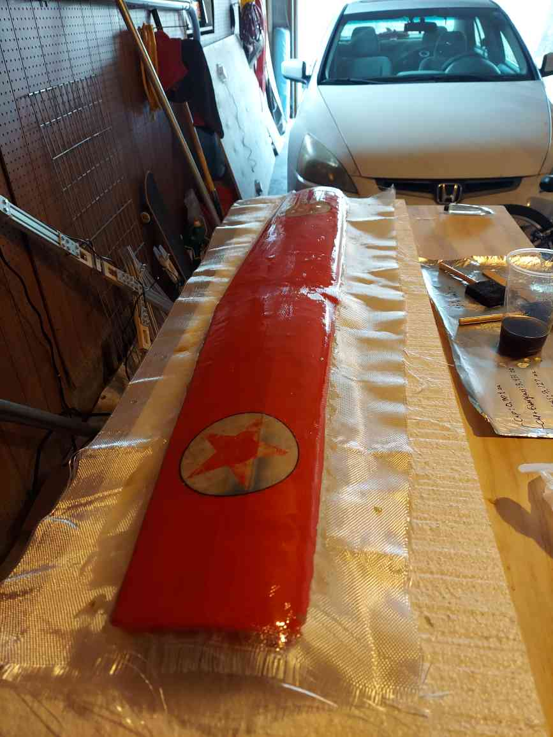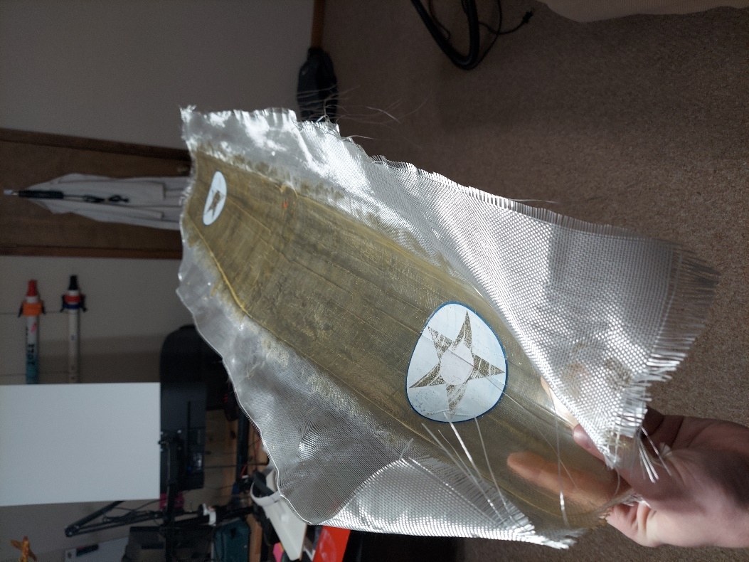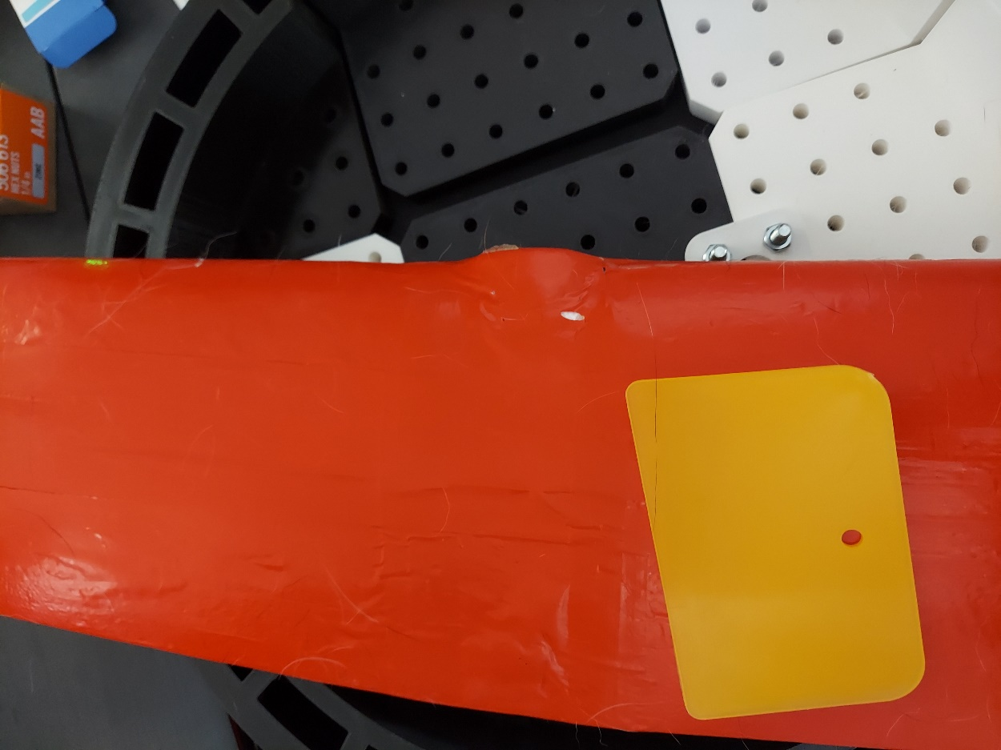

## Test 3 – 12/27/2023

* Fiber – Bondo fiberglass by 3M (PN: 20128)
* Matrix – Bondo fiberglass resin and hardener combo by 3M (PN: 20124)
* Vendor – Home Depot
* Description:
  + Unrelated to tests 1 and 2. This test is judging the releasability of the existing composite chemicals from Bazic sealing tape. The mold is a flat plate made of foamboard covered in non-overlapping sealing tape.
    - This tape might be cheaper than PVA plastic film and its adhesive so I can strictly fit it to my mold surfaces.
  + This test is also judging how well smooth printed PLA bonds to fiberglass surfaces during the curing process. A dummy print was placed onto the fiberglass and resin right after applying the resin.
  + The fiberglass unbonded from the tape with relatively little effort. The tape did not tear at all, but it did detach from the foamboard underneath.
  + The 3d print exhibited strong adhesion in the shear directions but not in the tensile direction.
* Quality – NA/10
  + This was a side-test and I cannot assign a quality rating since it was not designed to be a wing.
* Lessons learned:
  + For good bonding with PLA, some manufacturing tricks are needed. Likely involving roughing up the bonding surface and/or beveling the resin around the print. Could also try an intentional standoff distance from the fiberglass.
  + For a repeatable foamboard flat mold, better adhesive for the tape is ideal, but the surface is relatively good at releasing the composite.
* Pictures:

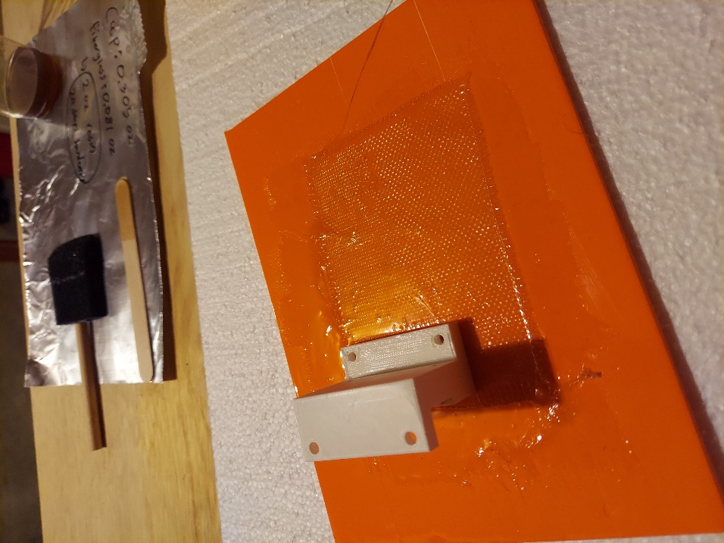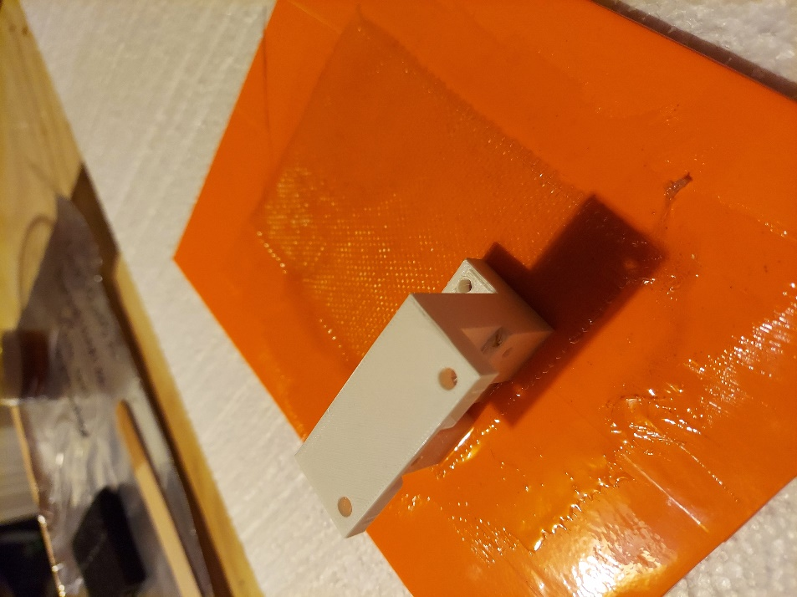

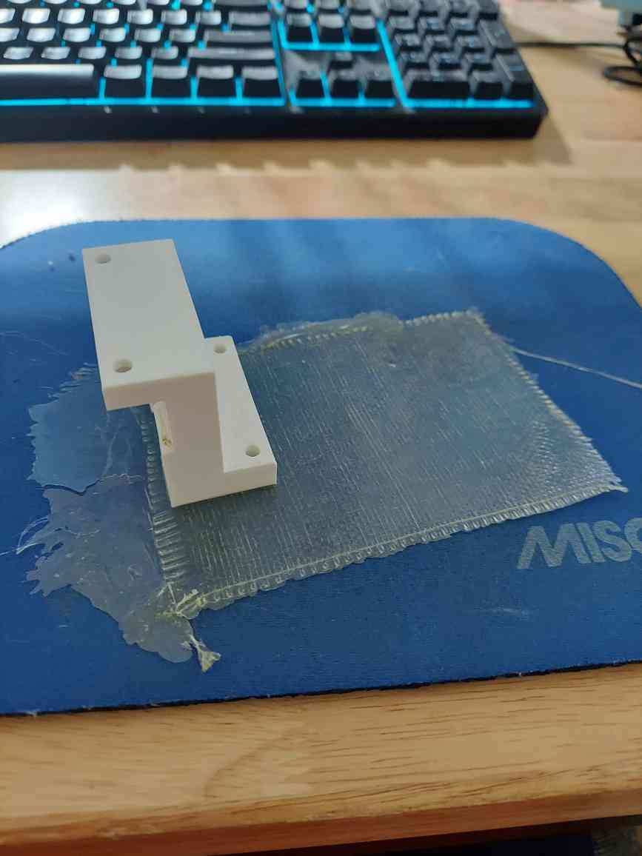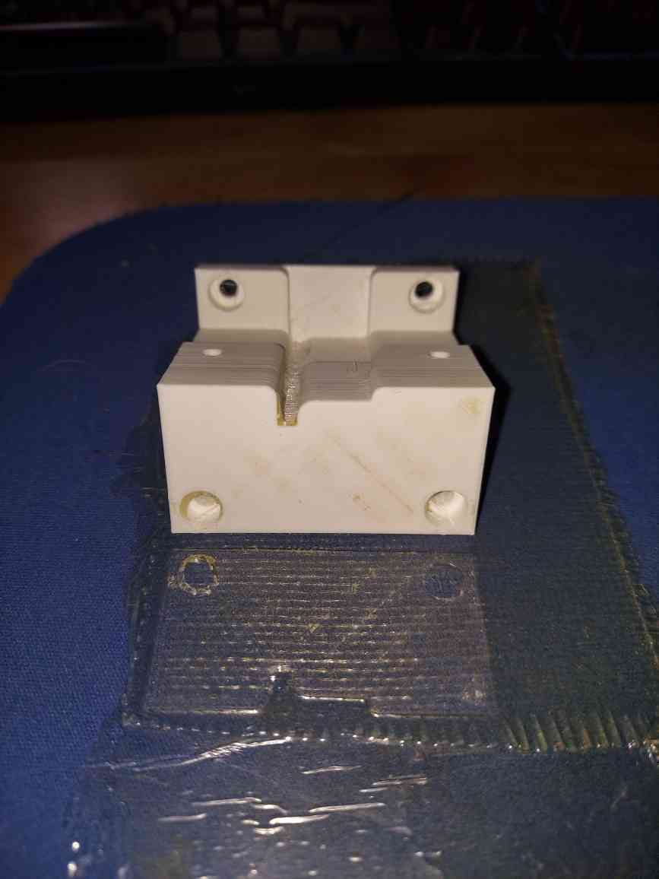

## Test 4 – TBD